Electronics Documentation

1. Electronics Block Diagram
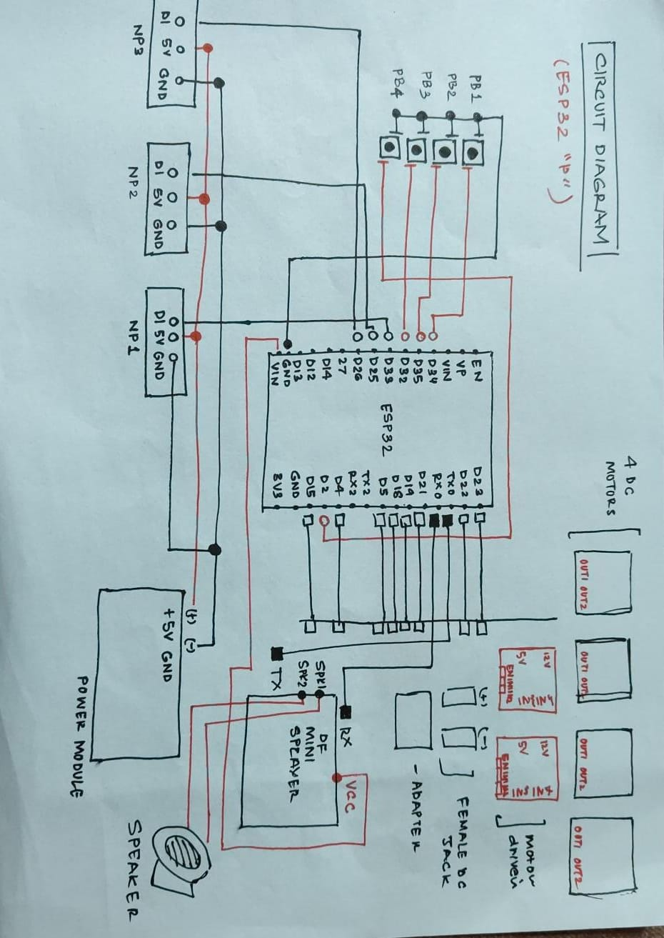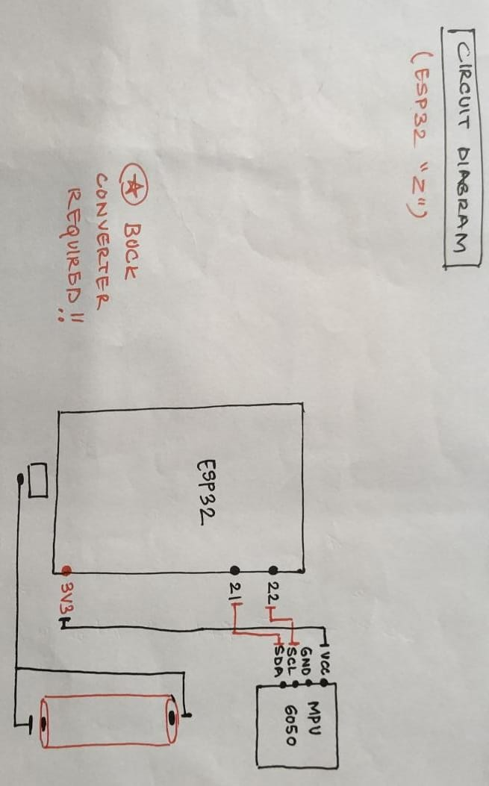

2. Components Table
Component | Quantity | Purpose | Justification
ESP32 | 2 | Main control and wireless communication | Chosen for built-in WiFi and ESP-NOW support, allowing wireless communication between wand and main system without extra modules
MPU6050 Sensor | 1 | Motion sensing (tilt and rotation) | Combines accelerometer and gyroscope in one module, making it compact and suitable for gesture detection inside the wand
DFPlayer Mini | 1 | Audio output | Small and sufficient for voice playback in a contained setup like the hat
NeoPixel LED Rings (16 LEDs each) | 3 | Visual feedback for wand selection | Individually addressable LEDs allow precise control over color and animation, useful for highlighting a selected wand
DC Motors | 4 | Physical movement of objects | Used to create the illusion of objects lifting and dropping, simple to control and sufficient for prototype-level actuation
Motor Drivers | 2 | Control direction and speed of motors | Required to handle higher current for motors and allow bidirectional control using ESP32 signals
Push Buttons | 4 | User input for quiz responses | Simple and reliable input method for discrete options (A, B, C, D)
Lithium-ion Battery | 1 | Power supply for wand | Enables wireless operation of the wand, making the interaction more natural and unrestricted

